BATCH ID: B5-5M1E

ROLL NO: CITC1904065

NAME: AISHWARYA B

CODE:

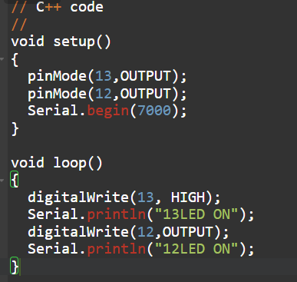

SIMULATION:

